Name
Professor
Institution Affiliations
Course Title
Date
Trends in Economics
Economics have grown over the few past decades by economists who have been recognized by the congress for providing to the press real day-to-day issues trending in economics. This has been enabled by the increased empirical environment surrounding economic research. With the help of the internet connections, the data bases have gained disparate sources and economical computing capability to crunch the numbers; hence economists are kept tuned to the current and real-world data, theoretical tests and models which are on the trend in economics.
This research paper analyzes the trends occurring in different stages and categories of economics over the past decades. Using data from research institutions such as RePEc and all relevant journals of economic literature, the paper investigates and analyzes the different economic categories over which economics have developed over the previous years. With the assistance of data from environmental and finance sectors, the substantiality of the research has been increased across the time of investigations. Upon the description of the information accumulated and provided that evidence on the current publicized developments in economics, then our results are compared with the current writings in economics, Pulina, et al, pg. 6725).

Research questions
- What are the trends in economics?
- What factors have facilitated the trends in economics?
- How have the trends in economics benefited economists across the world?
- What are the predicted trends in the coming years?
- What is the recommendation to economists on adapting trends in economics?
Key words
- Economic trends in economic research,
- impacts of citation in economic journals and environmental economics magazines
Data sources
We accumulated our information from Research Papers in Economics (RePEc). RePEc devours growth to an important foundation of wide range of knowledge and ranking in economics because of its authentic publishers and academic centers. The institution is founded on an active motto, with registered authors, academic institutions, and publishers, who provide accurate information which is networked over a wide geographical area.
This approach to data collection has a great benefit that assures an open transfer of work and references to different writers and articles. Almost 20% of the RePEc articles have been classified into different codes by the JEL. This has increased the share of respective websites for these journals hence the aspect of the weight of the different classifications generates a minute effect. The impact factor of the definitions from RePEc is same as the one published officially by the Journal Citation Reports by Thomson Reuters. Therefore, RePEc provides real details on the trends in economics, (Stock, pg. 645).
Results
The average share of articles from the different subject groups in the past decade has produced the highest level of relevant data in economics. However, there was a decline in the amount of publications which have been done during this decade in the category N of the JEL.
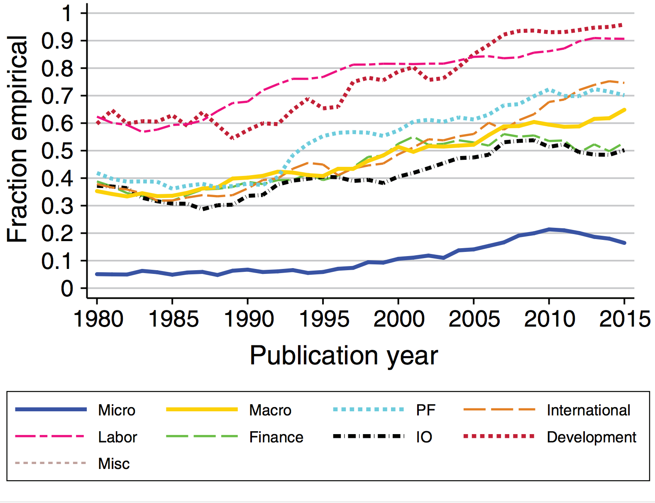
The American economic review
Most importantly, we refreshed the information of on the normal rate portions every article by different categories. JEL class N becomes just certain class with an advanced increment. In supreme positions, the topic bunch "Budgetary Economics" took the biggest offer in mid-2000s. It therefore supplanted the JEL class Q, which occupies a portion of 13.45% of the entire financial aspects documents in our informational collection. Quality-weighted the biggest portion of documents is however in class G, holding 14.96%. However, through our excellence subjective outcomes we affirm that this JEL classification has a place with the one with the biggest increase, (Serviette, et al, pg.25). Nevertheless, here is a gigantic increment in the portion of documents distributed in the examination ground "Rural and Natural Resource Economics, Environmental and Ecological Financial matters". This additional is for the most part determined by JEL sub-classifications Environmental Economics, Energy and Agriculture. Additionally on ascent are documents of the topic bunches "General Economics and Teaching" (An) and "Monetary Economics" (G). Records from Kelly and Bruestle show a huge contrast for their quality-weighted outcomes.
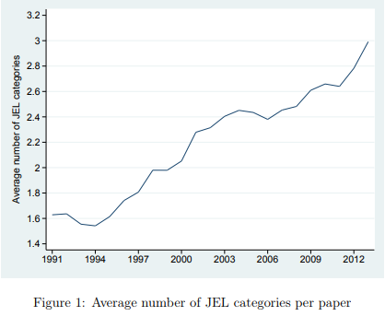
In a subsequent advance, we study the normal quantity of JEL classifications that are expressed per document. Along these lines, Figure 1 demonstrates an unmistakable increment somewhere in the range of 1991 and 2013. For this sub analysis we utilize similar informational collection involving 219,067 articles. We examined the causes of this expansion by methods for a Poisson relapse by the subordinate adaptable being the whole of JEL classifications expressed for each paper, (Rath, et al, pg.900).
However, smaller scale established macroeconomic papers are a special case in this pattern. She discovers every single other subject to ensure a comparative steady portion. In opposite, we discover in our informational collection a minor increment of the portion of macroeconomic documents. In any case, our quality-weighted outcomes show to a decreasing significance of macroeconomics inquires about. Fourcade, Ollion, and Algan (2015) examine the association of distributions in five top financial matters diaries to related trains by breaking down reference tallies. They locate a diminishing commitment of financial matters in scientific and measurable fields, while sociologies and particularly fund developed in significance over the most recent fifty years. The expanding significance of budgetary financial aspects is in accordance with our outcomes.

Conclusion
However, smaller scale established macroeconomic papers are a special case in this pattern. She discovers every single other subject to have a relative steady share. In opposite, we find in our informational collection a slight increment of the portion of macroeconomic papers. In any case, our quality-weighted outcomes show to a decreasing significance of macroeconomics inquires about. Fourcade, Ollion, and Algan (2015) examine the association of distributions in five top financial matters diaries to related trains by breaking down reference tallies. They locate a diminishing commitment of financial matters in scientific and measurable fields, while sociologies and particularly fund developed in significance over the most recent fifty years. The expanding significance of budgetary financial aspects is in accordance with our outcomes.

Work cited
Saviotti, Pier Paolo, and J. Stanley Metcalfe. "Present development and trends in evolutionary economics." Evolutionary theories of economic and technological change. Routledge, 2018. 1-30.
Rath, Katharina, and Klaus Wohlrabe. "Recent trends in co-authorship in economics: evidence from RePEc." Applied Economics Letters 23.12 (2016): 897-902.
Stock, Wendy A. "Trends in economics and other undergraduate majors." American Economic Review 107.5 (2017): 644-49.
Pulina, G., et al. "Invited review: Current production trends, farm structures, and economics of the dairy sheep and goat sectors." Journal of dairy science 101.8 (2018): 6715-6729.

